Bits on the Track

By: Joseph Joy

Answer: SimSig

The 0/1 direction decisions needed to guide each train leave a binary trail on the track. This is illustrated below by the trail of bits left by train **#**, which starts at the green station, makes its way eastward passing through the blue junction points (switches) with junction point decisions also shown in blue (0:left track, 1:right track, relative to direction of train travel). It then loops around and heads back west, passing through the orange junction points with junction points shown in orange. The seven-digit bit trail generated is **1100111**, which is 67 hex. Note that crossing a westward junction while going eastward and vice versa are ‘no-ops’.

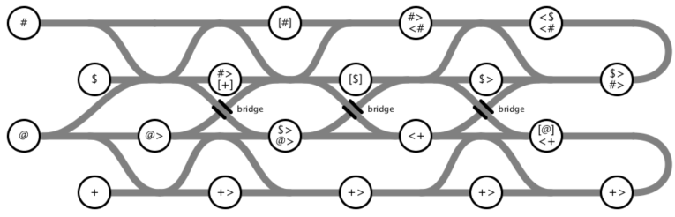

**1**

**1**

**0**

**0**

**1**

**1**

**1**

Each train’s binary trail identifies an ASCII letter.

|  |  |  |  |
| --- | --- | --- | --- |
| **Train** | **Bit Pattern** | **Hex** | **ASCII Character** |
| # | 1100111 | 67 | g |
| $ | 1101001 | 69 | i |
| @ | 1010011 | 53 | S |
| + | 1101101 | 6D | m |

The coded answer is **@ $ + @ $ #**, which spells out **SimSig**. SimSig is the name of a sophisticated railway signaling simulator game created by Geoff Mayo. A pro version of the game is used to train (no pun intended) professional signal operators in the UK.